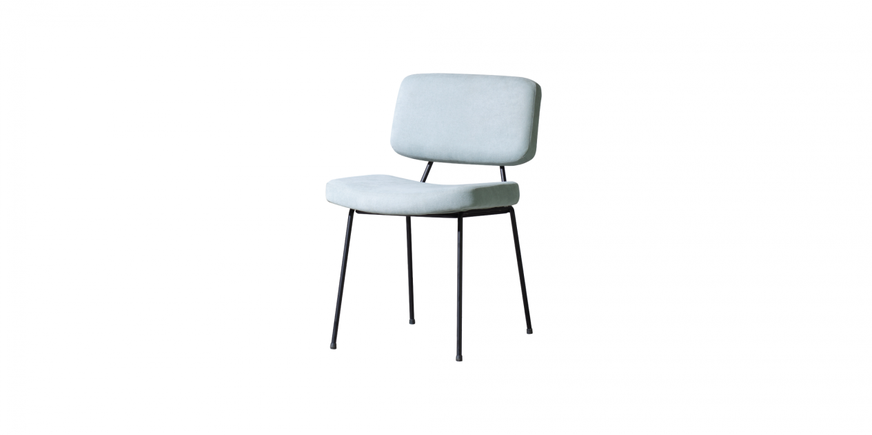

$105,38A streamlined chair model, focusing on comfort for the user with a gently curved seat cushion, combined with a low backrest that slightly reclined to create a feeling of relaxation but still ensures its ergonomics for the user.

